Appendix B
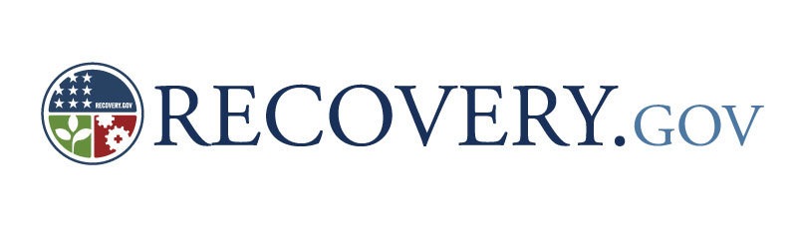
This product was financed through a grant from the Ohio Environmental Protection Agency and the United States Environmental Protection Agency with funds from Section 604b of the Clean Water Act.

Stream Database Guide

Stream Database Guide
Introduction

The OKI Stream Database is a comprehensive spreadsheet on the watersheds of Butler, Clermont, Hamilton and Warren counties, which comprise the Ohio portion of the OKI region. Listed with each watershed is information on its location, identity, designated beneficial uses, water quality, wastewater treatment plants, and conservation efforts. The database consists largely of information culled from the Ohio 2014 Integrated Water Quality Monitoring and Assessment Report, a biennial document prepared by the Ohio EPA in compliance with Sections 303(d) and 305(b) of the Clean Water Act. This guide explains the terminology and concepts of each column heading in the OKI Stream Database.

Note: This document is not a glossary and does not address terminology in alphabetical order.

How to Use This Guide

This guide explains the Stream Database contents in order, from left to right, of the column headings in the first two worksheet tables. These worksheets address Watershed Assessment Units in the WAU Table, and Large River Assessment Units in the LRAU Table. Column headings for these two worksheets are mostly identical, and some small differences are explained in order of appearance. The eight remaining worksheets provide supplemental data and are explained where their topics arise.

Hydrologic Unit Codes (Watershed Assessment Unit (WAU) Table)

Hydrologic Unit Codes (HUCs) are a systematic method of naming every watershed or drainage basin located within the United States. HUC watershed boundaries define areas that are drained by streams or rivers, and typically follow topographic features such as ridge lines. HUC watersheds are organized by a hierarchy of levels, based on size. Each large watershed is divided and subdivided for a total of six levels of watershed.

Each HUC watershed is assigned a series of two digit codes that make up an entire Hydrologic Unit Code. The first two digits represent the largest size of watershed; the next two digits represent a smaller division of that watershed, and so on. If both digits in a set are zeros, then that level is considered to be equivalent to the level above it. Figure B-1 below is an example.

Figure B-1: Diagram of a 12-digit Hydrologic Unit Code (HUC-12)

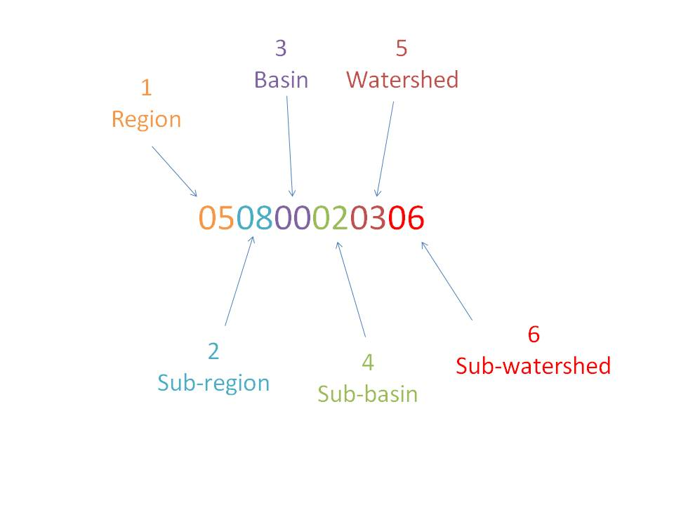

Level 1

Level 1 consists of major geographic regions, of which there are 21. These regions contain the drainage area of a major river, or series of rivers.

Level 2

Level 2 consists of sub-regions which are sub-divisions of the first level. Sub-regions can be the area drained by a river system, a reach of a river and its tributaries, a closed basin, or a group of streams forming a costal drainage area.

Level 3

Level 3 consists of basins that sub-divide or are equivalent to the sub-regions. These basins used to be called accounting units, and are sometimes referred to as such. Notice the occurrence of a double zero. As stated before, this indicates that the basin in this case is identical to the sub-region.

Level 4

Level 4 units are called sub-basins or cataloging units, and consist of a surface drainage basin, a combination of drainage basins, or a distinct hydrologic feature.

Level 5

Level 5 watersheds range between 40,000 and 250,000 acres.

Level 6

This is the smallest level, and is similar to level 5 except that it is smaller. These can be considered sub-watersheds, and they are typically 10,000 to 40,000 acres.

The OKI Stream Database is organized by 12-digit, level-6 sub-watersheds. They are also the units used by the Ohio EPA to assess water quality.

Further information can also be found at:

http://water.usgs.gov/GIS/huc.html
http://imnh.isu.edu/digitalatlas/hydr/huc/huctxt.htm

Watershed Assessment Units (WAU Table)

The first worksheet table in the Stream Database is labeled the Watershed Assessment Unit (WAU) Table. This terminology is taken from the Ohio 2014 Integrated Water Quality Monitoring and Assessment Report. Each watershed assessed in Ohio’s 2014 Integrated Report is identical to a 12-digit HUC watershed (explained above). These units are identified by their HUC and given a Description. WAU descriptions are further addressed later in this guide.

Large River Assessment Units (LRAU Table)

The 12-digit watersheds reported exclude any sections of what are considered large river mainstems. These waters are reported separately in Ohio as Large River Assessment Units (LRAU). These units consist of 25- to 45-mile sections of river.

Large river units are assigned 12-digit codes similar to the HUC codes used. Any 12-digit code that has a 90 as its fifth level is considered a Large River Assessment Unit. These codes are in no way part of the HUC system. They are assigned by the Ohio EPA with 12 digits for convenience. The LRAUs are listed separately in the LRAU table to avoid confusion. The LRAU table and the HUC table are almost identical, except for special cases such as using area for watersheds, and length for LRAUs.

Hydrologic Unit Name and Large River Assessment Unit Name

Hydrologic Units are usually named by a major stream located within the watershed, or a local hydrologic feature. Sometimes a local cultural or political feature can be used instead. These names are not necessarily unique, as stream names are not always unique. This makes it vital that all watershed identities are confirmed using Hydrologic Unit Codes. Large River Assessment Unit names are designated by the Ohio EPA and typically contain river names and river miles.

Named Streams

These are the streams located within each 12-digit watershed. Only streams with names are listed, although there are often many unnamed streams and tributaries. These can be observed using a map or the OKI streams layer. The OKI Stream Database also has a Streams Table, which contains all streams that are described in the Ohio Administrative Code rule 3745-1-07 (see Beneficial Use Designations). For each stream or stream segment the following is listed: name, receiving stream, length, designated uses, and HUC watershed(s). If a stream is not perennial then the word intermittent will be located next to stream’s name in parentheses in the Streams Table.

Location

A column is assigned to each of the four Ohio counties in OKI’s planning region: Butler, Clermont, Hamilton, and Warren. An asterisk is placed under a county if all or part of the watershed is located in that county. Many watersheds are located in multiple counties.

Area and Length Measurements

Area and Length are divided into several categories. Total area is given in square miles. For LRAU’s, total area is the area drained by the specified river mainstem. Estimated figures are stated for the regional area and length of watersheds that extend outside the OKI region.

Total Maximum Daily Load (TMDL) Status

Under section 303(d) of the Clean Water Act, states are required to develop lists of impaired waters. These are waters that are too polluted or otherwise degraded to meet the water quality standards set by states. The law requires that these states establish priority rankings for waters on the lists and develop Total Maximum Daily Loads (TMDLs) for these waters. A TMDL is a calculation of the maximum amount of a pollutant that a water body can receive and still safely meet water quality standards.

Watersheds with a TMDL in progress will be in one of these phases: Assessment Phase, Load Analysis Phase, Nearing Completion, Some Implementation Proceeding, and Final Report Approved by U.S. EPA and Being Implemented. If there is not a TMDL in progress and one is required, there will be a projected date that the TMDL will begin. For more information on the TMDL process of Section 303 (d) of the Clean Water Act go to the following websites:

http://www.epa.ohio.gov/dsw/tmdl/index.aspx#Ohio%27s%20303%28d%29%20List%20and%20Schedule
http://www.epa.gov/waterscience/standards/rules/303.htm

Beneficial Use Designations (Water Supply, Recreation, and Aquatic Life)

These designations are in accordance with Ohio Administrative Code rule 3745-1-07, and they are each described in paragraph B. Every stream in Ohio must be assigned at least one beneficial use in each category. The beneficial use categories and associated designated uses are shown in Figure B-2 below.

Figure B-2: Beneficial Use Categories
1. Aquatic Life Habitat:
WWH: | Warmwater Habitat
EWH: | Exceptional Warmwater Habitat
MWH: | Modified Warmwater Habitat
SSH: | Seasonal Salmonid Habitat
CWH: | Coldwater Habitat
LRW: | Limited Resource Water
2. Water Supply:
PWS: | Public Water Supply
AWS: | Agricultural Water Supply
IWS: | Industrial Water Supply
3. Recreation
BW: | Bathing Water
PCR: | Primary Contact Recreation
SCR: | Secondary Contact Recreation

It may be obvious that the Stream Database does not perfectly reflect this list when 303 (d) listing categories (described below) are assigned. This is no mistake. All recreation and aquatic life uses are assessed by the Ohio EPA, but the only water supply use assessed is public drinking water. Ohio EPA also assesses human health based on the purity of fish that may be eaten, but fish consumption is not listed in administrative code as a beneficial use. This parameter is based on fish tissue analysis for mercury and polychlorinated biphenyls (PCBs). Consuming fish from these streams could be a threat to human health.

More information on beneficial uses and antidegradation (explained below) can be found on the Ohio EPA site for Ohio Administrative Code rule 3745-1:

http://www.epa.state.oh.us/dsw/rules/3745_1.aspx

Note: When visiting this site you may notice that the Primary Contact Recreation use is split into three classes. This is a recent development, and these new uses have not yet been assigned to all appropriate Ohio streams. These new uses will likely be integrated into the Stream Database as soon as they become available.

303(d) Listing Category

These categories are assigned by the Ohio EPA, and reflect U.S. EPA guidance for the 303 (d) listing process. The 303 (d) list functions as a way of keeping track of streams that are deemed impaired. Only streams that are considered both impaired, and lacking adequate control measures to fix the impairment, are placed on the list.

Assessment categories are designated based on attainment of a stream’s beneficial uses. Beneficial uses that fit into the categories of aquatic life, recreation, and water supply are assigned to each stream in Ohio. When stream monitoring occurs, variables that affect a stream’s attainment of these uses are sampled. Guidelines are described by the U.S. EPA or state agencies (Ohio EPA) that set standard limits which determine whether a measured variable is posing a threat to the beneficial uses of a stream.

A category is assigned to each beneficial use of a stream. Figure B-3 below lists and describes these categories. When a beneficial use of a stream is assigned category 5, it is placed on the 303 (d) list. Figure B-3: Category Definitions for the 303(d) list

Causes and Sources of Impairment

Causes of impairment are listed for public drinking water and human health. Both causes and sources are listed for aquatic life. The causes of impairment indicate which parameter(s) do not satisfy water quality standards. A cause of impairment addresses the question: What is the agent responsible for water quality degradation? The sources of impairment indicate nearby activity that is contributing the cause of impairment. A source of impairment addresses the question: Where do the causes of impairment originate? No cause of impairment is listed with recreation because only one parameter (E. coli) is measured.

Harmful Algal Blooms

Harmful Algal Blooms (HABs) are a significant water quality issue because they can potentially produce cyanobacteria toxins capable of causing irritation, illness or sometimes even death in pets, livestock and humans. Most HABs are caused by planktonic bacteria, which are suspended in the water and rely on currents to move them. The term “algal” is a little misleading because the organisms that normally make up HABs are actually cyanobacteria, which are commonly referred to as “blue-green algae,” and are not true algae

The following table in Figure B-4 shows the cyanobacteria levels at which Ohio authorities activate four types of advisories for Harmful Algal Blooms in public water bodies. The bottom table in the “Harmful Algal Blooms” section of the OKI Stream Database lists the types and levels of cyanobacteria toxin levels measured recently at East Fork Lake in Clermont County. Also known as Harsha Lake, the state water body serves as a source of public drinking water from a surface water intake and as a place for public recreation at lakeside campgrounds and beaches

Figure B-4: Ohio’s Harmful Algal Bloom Advisory Levels

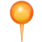The Recreational Public Health Advisory -- A Recreational Public Health Advisory sign will be posted at beaches when toxin levels exceed the recommended threshold, warning individuals who are elderly or very young and people with compromised immune systems that swimming or wading is not recommended.

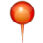A No Contact Advisory -- A No Contact Advisory sign will be posted when toxin levels exceed the recommended threshold and there are one or more probable cases of human illness or pet deaths attributable to HABs. This sign will warn people that unsafe toxins are present in the water and to avoid any contact.

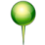Drinking Water Advisory -- Do Not Drink -- If microcystin, anatoxin-a, cylindrospermopsin or saxitoxin is found above drinking water thresholds in the finished water of a public water system, the water system will issue a public notice for a Do Not Drink Advisory. The public water system may end a Do Not Drink Advisory when algal toxin levels are below the drinking water thresholds in two consecutive samples collected at least 24 hours apart.

Drinking Water Advisory -- Do Not Use -- If microcystin, anatoxin-a, cylindrospermopsin or saxitoxin is found above drinking water thresholds in the finished water of a public water system, the water system will issue a public notice for a Do Not Use Advisory. The public water system may end a Do Not Use Advisory when algal toxin levels are below the drinking water thresholds in two consecutive samples collected at least 24 hours apart.

Numeric Cyanotoxin Thresholds
 | All threshold values are reported in ug/L
Type of Advisory | Microcystin * | Anatoxin-a | Cylindrospermopsin | Saxitoxin*
Recreational Public Health Advisory | 6 | 80 | 5 | 0.8
Recreational No Contact Advisory** | 20 | 300 | 20 | 3
Drinking Water: Do Not Drink Advisory | 1 | 20 | 1 | 0.2
Drinking Water: Do Not Use Advisory | 20 | 300 | 20 | 3
*Microcystin and Saxitoxin thresholds are intended to be applied to total concentrations of all reported cogeners of those toxins.
**A No Contact Advisory is issued when toxin levels exceed the recommended threshold and there are one or more probable cases of human illness or pet deaths attributable to HABs.

Notes: ppb - parts per billion; ug/L - micrograms per liter; Microcystin, Anatoxin-a, Cylindrospermopsin and Saxitoxin are the Cyanotoxins tested for at Ohio state park beaches and at public water systems.

Source: Ohio EPA website on map of current Harmful Algal Bloom advisories

PDWS

The 2014 Integrated Report is the fourth reporting cycle to include assessment of the public drinking water supply (PDWS) beneficial use. Ohio continues to look for connections between Clean Water Act and Safe Drinking Water Act (SDWA) activities and leverage the programs to clean up and protect drinking water sources. Acknowledgement of the public water supply use and identification of impaired waters provides an effective issue in which to engage the public and stakeholders in watershed-wide planning and implementation activities. Conversely, the public water systems can be effective partners in these efforts and stand to benefit through reduced treatment costs, reduced risk to human health, and credits toward compliance with new SDWA regulations via source water controls in the watershed.

Assessments for each public water system were completed for nitrate, pesticide, and new algae (cyanotoxin) indicators. Assessments included in this cycle are based primarily on treated water quality data and to a limited extent other source water quality data available from Ohio EPA and external sources. Information used to complete assessment determinations include public water system treatment information, intake location, number and type of reservoirs, and water quality data. Assessments were completed for stream sources and in-stream impounded reservoir sources with active drinking water intakes.

Each assessment will result in identification of one of three attainment categories: Impaired, Full Attainment, and Not Assessed-Insufficient Data. For assessment units with multiple PDWS zones, the attainment statuses of all zones are combined and the lowest attainment status applied to determine the PDWS assessment status for the entire assessment unit. That is, the overall AU assessment status is considered “Impaired” if any of the PDWS zones have an impaired attainment status. Conversely, the overall assessment status for the AU could be listed as “Full Support” only if sufficient data for at least the nitrate indicator was available to determine the attainment status for all PDWS zones within the AU.

Full attainment waters will further be evaluated for water quality conditions placing them on a “watch list.” Source waters are placed on the “watch list” where water quality was impacted but not at a level that indicates impairment. Waters may remain on the watch list based on historical data if current raw water data or applicable finished water quality data are not available. While these waters are still considered in full attainment of the PDWS use, they will be targeted for additional monitoring and more frequent assessment if resources are available.

Antidegradation Category

The Antidegradation Rule is defined by the provisions in Ohio Administrative Code rule 3745-1-05. This rule describes the conditions under which water quality may be lowered in surface waters. Under this rule each state surface water body is assigned an Antidegradation category. This provides criteria for the permitting process to lower surface water quality. The categories are listed below with the definitions assigned to them in the Ohio Administrative Code. All waters in Ohio are considered General High Quality unless otherwise noted in the database.

Antidegradation Categories:

"General high quality waters" are wetlands categorized as category 2 or 3 in accordance with rule 3745-1-54 of the Administrative Code and other surface waters that are not specifically categorized limited quality waters, superior high quality waters, outstanding state waters, or outstanding national resource waters.

"Superior high quality waters" are surface waters that possess exceptional ecological values and that have been so categorized pursuant to paragraph (E) of this rule. Except as provided below, exceptional ecological values shall be assessed based upon a combination of the presence of threatened or endangered species and a high level of biological integrity. The following factors shall be considered in determining exceptional ecological value: providing habitat for Ohio or federal endangered species; providing habitat for Ohio threatened species; harboring stable populations of a declining fish species that coincide with the presence of suitable habitat for that species, or that coincide with an essential migration path between areas of suitable habitat for that species; and displaying a level of biological integrity equivalent to the exceptional warmwater habitat index of biotic integrity or invertebrate community index criteria values listed in rule 3745-1-07 of the Administrative Code.

Water bodies that exhibit a pattern of biological integrity equivalent to the index of biotic integrity and, where applicable, invertebrate community index scores of 56 or greater at most sites are characteristic of a near pristine aquatic habitat. Such waters, as well as other ecologically unique water bodies that have essentially undisturbed native faunas, but for which the biological criteria in rule 3745-1-07 of the Administrative Code do not apply, may be considered as possessing exceptional ecological values without the presence of threatened or endangered species.

"Outstanding state waters" are waters that have special significance for the state because of their exceptional ecological values or exceptional recreational values, and that have been so categorized pursuant to paragraph (E) of this rule. To qualify on the basis of exceptional ecological values they must meet the qualifications for superior high quality waters and be further distinguished as being demonstratively among the best waters of the state from an ecological perspective. To qualify on the basis of exceptional recreational values they must provide outstanding or unique opportunities for recreational boating, fishing or other personal enjoyment.

Note: Outstanding state waters have an E or and R after them in the stream database depending on weather they have exceptional ecological or recreational values.

"Outstanding national resource waters" are surface waters that have a national ecological or recreational significance, and that have been so categorized pursuant to paragraph (E) of this rule. National ecological significance may include providing habitat for populations of federal endangered or threatened species or displaying some unique combination of biological characteristics in addition to those factors listed in paragraph (A)(10)(b) of this rule. National recreational significance may include designation in the national wild and scenic river system.

"Limited quality waters" mean wetlands categorized as category 1 in accordance with rule 3745-1-54 of the Administrative Code and other surface waters of the state specifically designated in rules 3745-1-08 to 3745-1-30 of the Administrative Code as limited resource water, nuisance prevention, limited warmwater habitat, or modified warmwater habitat.

NPDES Permits

NPDES stands for National Pollutant Discharge Elimination System. This provision of the Clean Water Act prohibits discharge of pollutants into waters of the United States unless a permit is issued by the U.S. EPA or Ohio EPA. Each permit is identified with a unique number. These numbers and the associated facility names are listed in the Watershed Assessment Unit (WAU) Table of the OKI Stream Database.

Each NPDES permit number in the WAU Table is also a link to its associated cell in the NPDES Table of the OKI Stream Database. The NPDES Table contains NPDES and plant information for every major and most minor public facilities in the Ohio portion of the OKI planning region. Included are links to available permits, system addresses, receiving streams, design capacity, HUC-12 watersheds, and wastewater treatment plant coordinates.

All active permits in Ohio can be found at:

http://www.epa.ohio.gov/dsw/permits/npdes_info.aspx

Watershed Action Plans

A watershed action plan (WAP) itemizes the issues associated with a watershed, and makes goals to address these issues. These plans are created on a local community scale, with an emphasis on intercommunity cooperation within the watershed. WAPs have to be submitted to the state for review, and then must obtain state endorsement. The watershed action plans listed in the stream database provide the endorsement status, and are hyperlinked to an Ohio Department of Natural Resources ftp site where copies of the plans can be downloaded.

Here are the different levels of Watershed Action Plan (WAP) status:
- Full State Endorsement:

The WAP has undergone review by Ohio Department of Natural Resources (ODNR), Ohio Environmental Protection Agency (Ohio EPA), Ohio State University Extension, and other state officials as warranted, and all agree that the WAP has been developed according to Ohio EPA’s A Guide to Developing Local Watershed Action Plans in Ohio, including Appendix 8, and meets the U.S. EPA Nonpoint Source Program and Grants Guidelines for States and Territories. In short, the inventory is thorough, the scope is comprehensive, and actions are measurable, geographically and temporally specific, and will address identified water quality problems. The watershed entity receives an endorsement letter signed by the chiefs of ODNR Division of Soil and Water Conservation (DSWC) and Ohio EPA Division of Surface Water (DSW).

- Conditional Endorsement:
Until recently, “conditional endorsement” has been applied as a single designation and included WAPs that were either partially endorsable or close to full endorsement. Those WAPs classified with one of the following designations are considered “conditionally endorsed” for the purpose of grant or program eligibility. Both categories of conditional endorsement are intended to be temporary, and may be revoked with insufficient progress toward full endorsement.

- Full Endorsement Pending:

State reviewers agree that the WAP is close to achieving Full Endorsement in that the inventory is generally complete, the scope is sufficiently comprehensive, and most actions are measurable and closely related to identified water quality problems. Comments may be numerous yet relatively minor, and reviewers anticipate comments can be addressed in a relatively short timeframe. The watershed entity will receive a letter stating, “full endorsement is pending” (previously “conditional endorsement”) with comments and suggested revisions from DSWC and DSW staff. When re-submitted, the WAP will NOT undergo a fresh review. Instead, previous reviewers will check whether revisions have satisfactorily addressed concerns as expressed in the comment letter.

- Partial Endorsement:

The WAP is not comprehensive in addressing all major causes and sources of water quality impairment, or sections of the plan do not meet requirements related to specificity and measurable outcomes. However, a portion of the plan does merit Full State Endorsement criteria. The watershed entity will receive a letter signed by ODNR’s Division of Soil and Water Conservation and Ohio EPA’s Division of Surface Water staff granting “partial endorsement” (previously “conditional endorsement”) specifying the portions of the plan meeting full endorsement criteria, e.g., one or more specific sub-watersheds. The letter will also include comments and instructions for revising the plan in order to achieve full state endorsement. Partial Endorsement may necessitate a fresh review of the WAP, or portions therein, depending on the extensiveness of additions or revisions needed.

- No Endorsement

The WAP does not meet criteria for State Endorsement. The extensiveness or content of comments suggest that the planning process or the WAP document itself requires fundamental improvement.

Stewardship Organizations

These are local organizations that are involved in local water quality and water conservation efforts. The organizations usually associate with particular watersheds. The Stewardship section of the OKI Stream Database provides links to the organization websites.

Nonindigenous Aquatic Species Table

This table contains a list of 8-digit HUC watersheds in the OKI region, and the nonindigenous aquatic animals that have been observed in them. This data is collected and cataloged by the U.S. Geological Survey’s Nonindigenous Aquatic Species information resource, and is cataloged at this site:

http://nas.er.usgs.gov

Resources Table

This table contains links to the detailed resources used for the WAU Table and LRAU Table. The numbers correspond to the green numbers located at the top left of columns in the WAU and LRAU Tables. These green numbers are also links to the correct fields in the resources table.

